**ARYAMAN MISHRA**

**19BCE1027**

Use a video processing Software to perform – Trim video clips, crop video, rotate video, join video, add subtitles, and edit video dimension, bit rate, 3 hoursframe rate, sample rate, channel on a video.

Premiere Pro CC

Gdrive Link: <https://drive.google.com/file/d/1M_jqFVGbfmOTnn0Ga1wL3Nne7JsGrxqI/view?usp=sharing>

Video Link: https://www.youtube.com/watch?v=WBwvKGc9ySc

Trim video clips

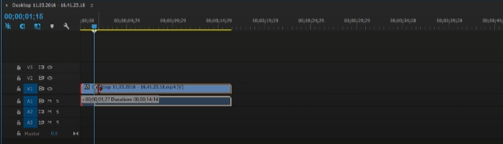

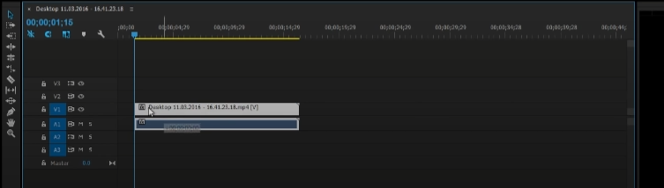

crop video

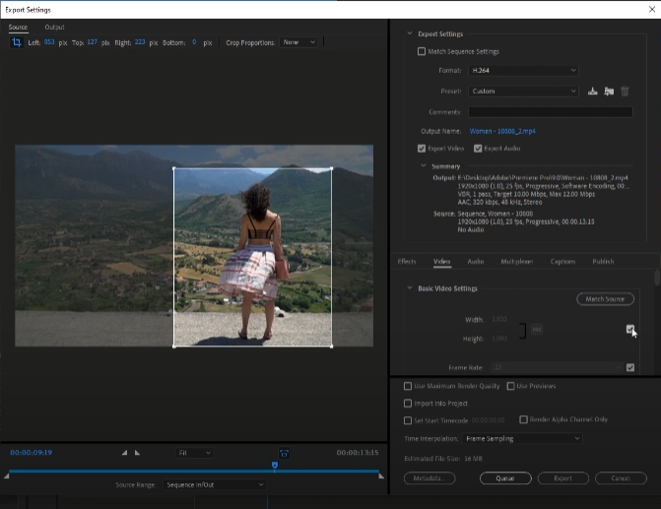

rotate video

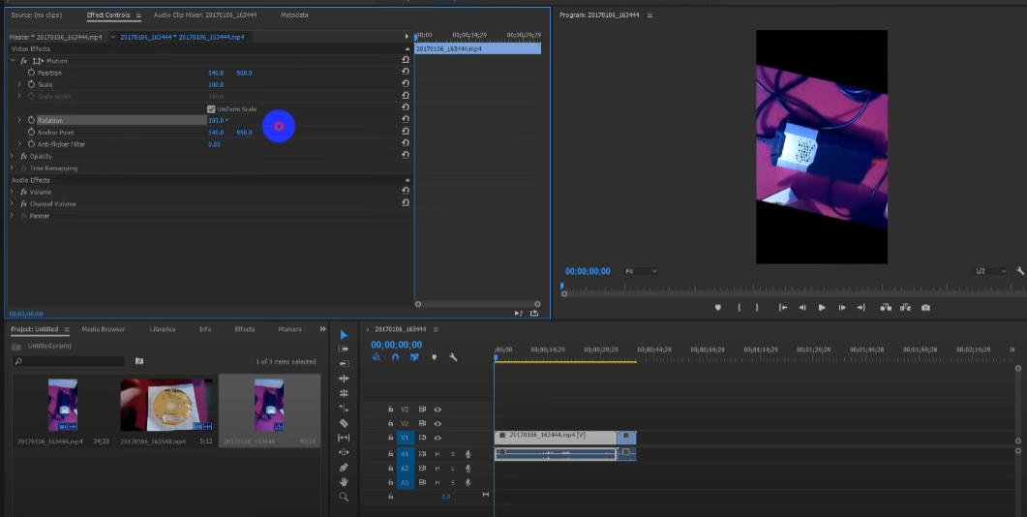

join video

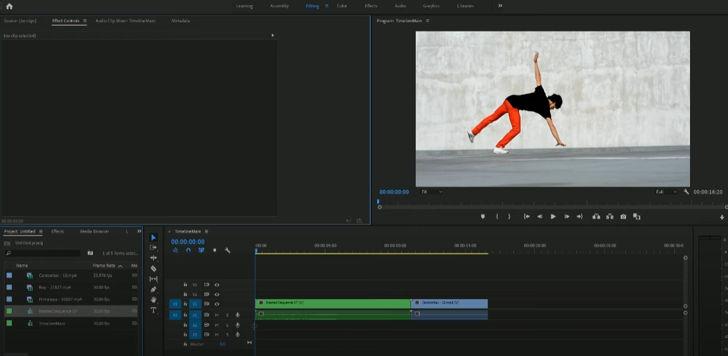

add subtitles

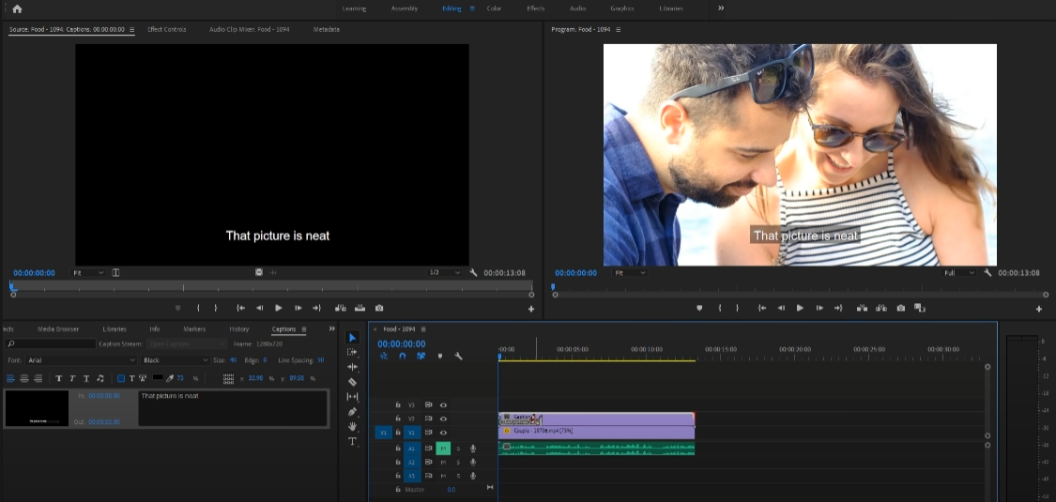

edit video dimension

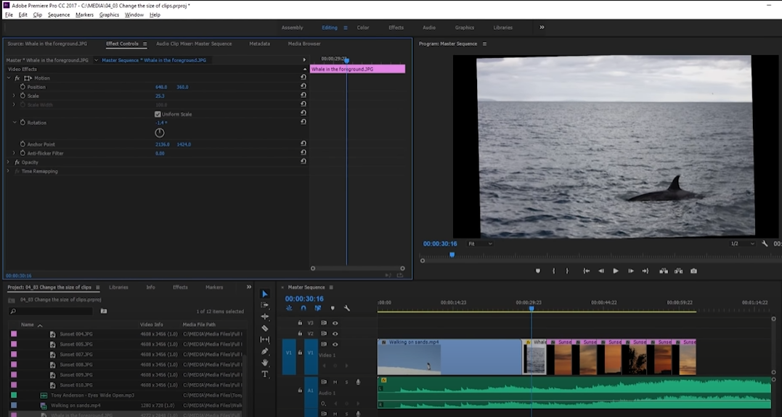

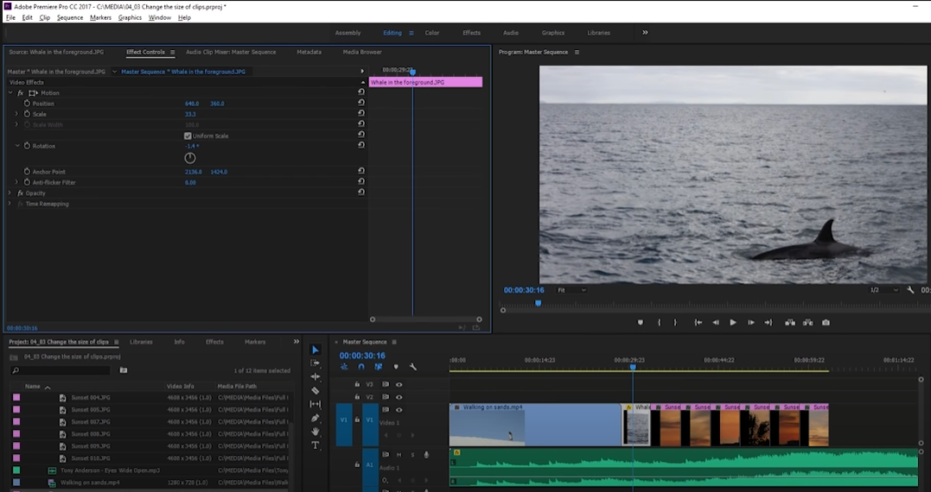

bit rate

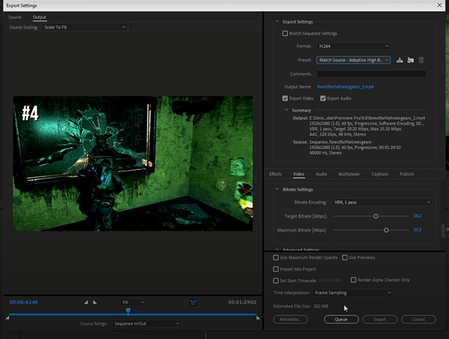

sample rate

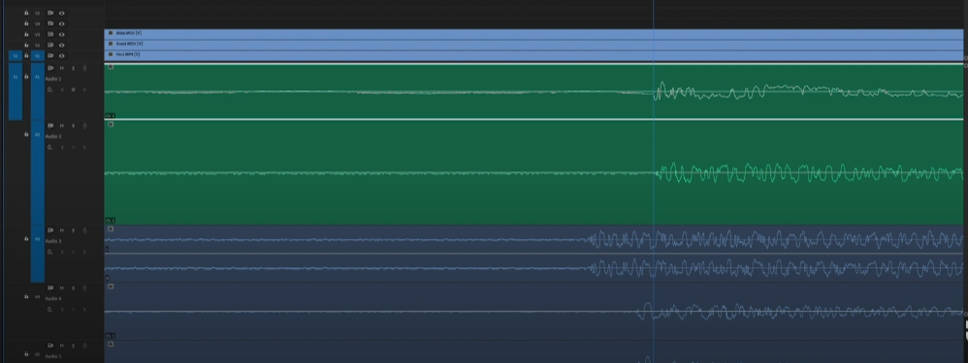

channel on a video

